Drupal Training Manual

2… Logging into the site
5… General Use Content Types
5… Structure
5… Recommended Authoring Steps
7… Specific Use Content Pages
Overview
Academic Department/Program
Events
News
People
Study Abroad Landing
Study Abroad Region
8… Components
8… Body
10… Column Layout
12… Image Carousel
13… Events Carousel
14… Accordion Tabs
16… People Carousel
18… Infographic Layout
20… News Carousel
21… Promotional Carousel
23… Net Price Calculator
24… WYSIWYG Section
25... Menu To Display

Logging into the site

1. Go to westmont.edu/edit to get started. Log in with your Westmont account. If you are already logged in to your Westmont account (via gmail or another app), your account will be created and you will be directed to the homepage.
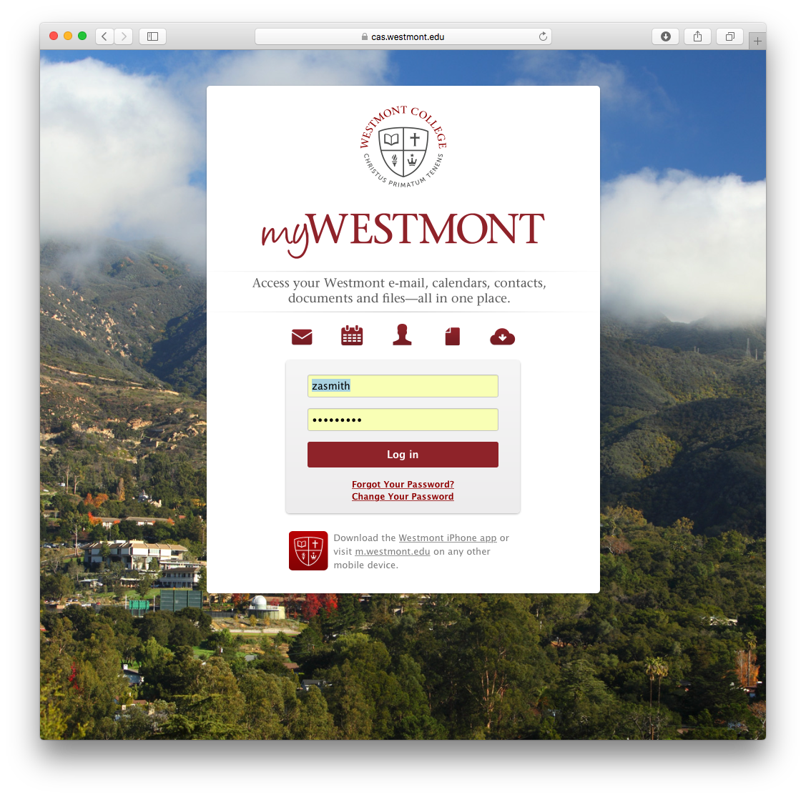
3. If this is your first time logging in, an administrator will now need to assign you to a group. Once they have done this, head back to westmont.edu/edit, log in if necessary, and click on “My Workbench” in the top left corner.
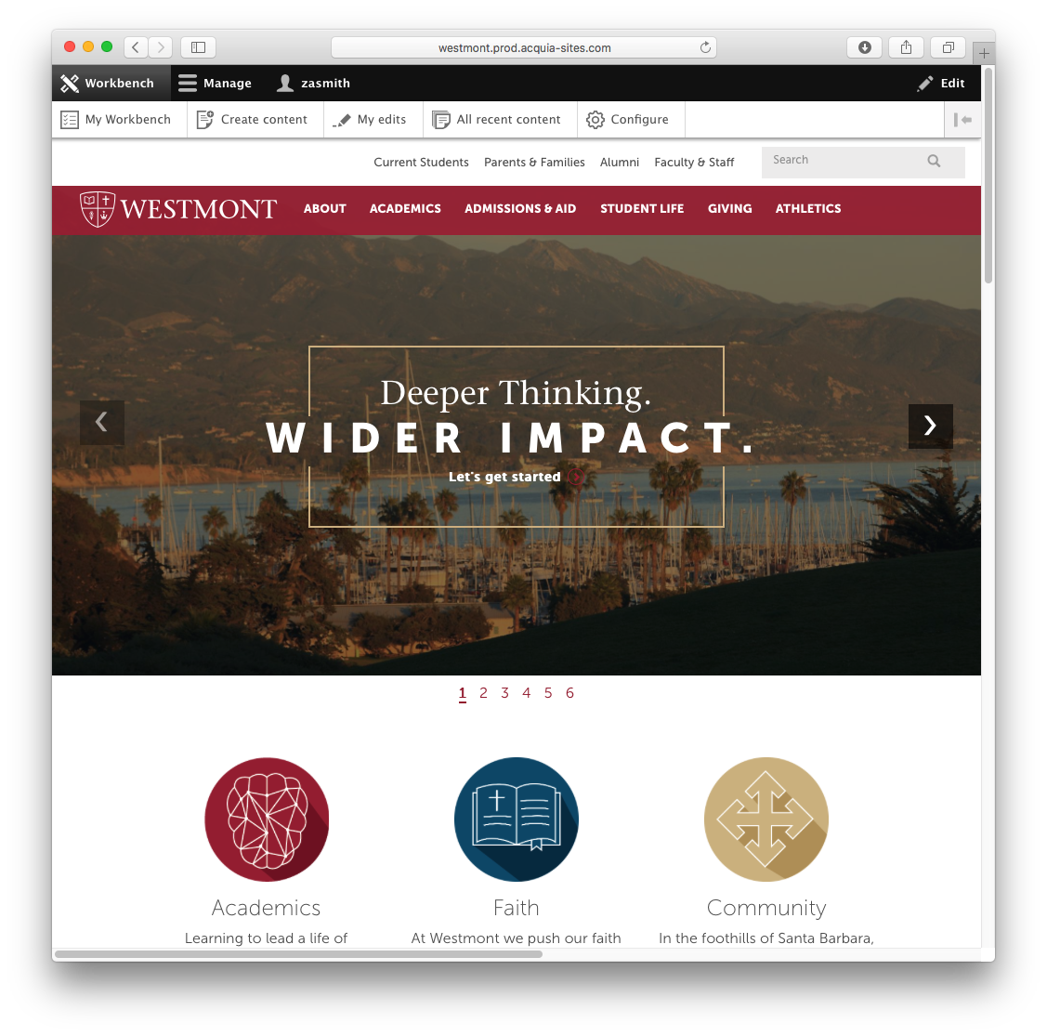
4. Here, you’ll see a list of “groups” you are a member of. To gain access to a group, please open a support ticket at support.westmont.edu. Click “View Content” to see the pages within your group.
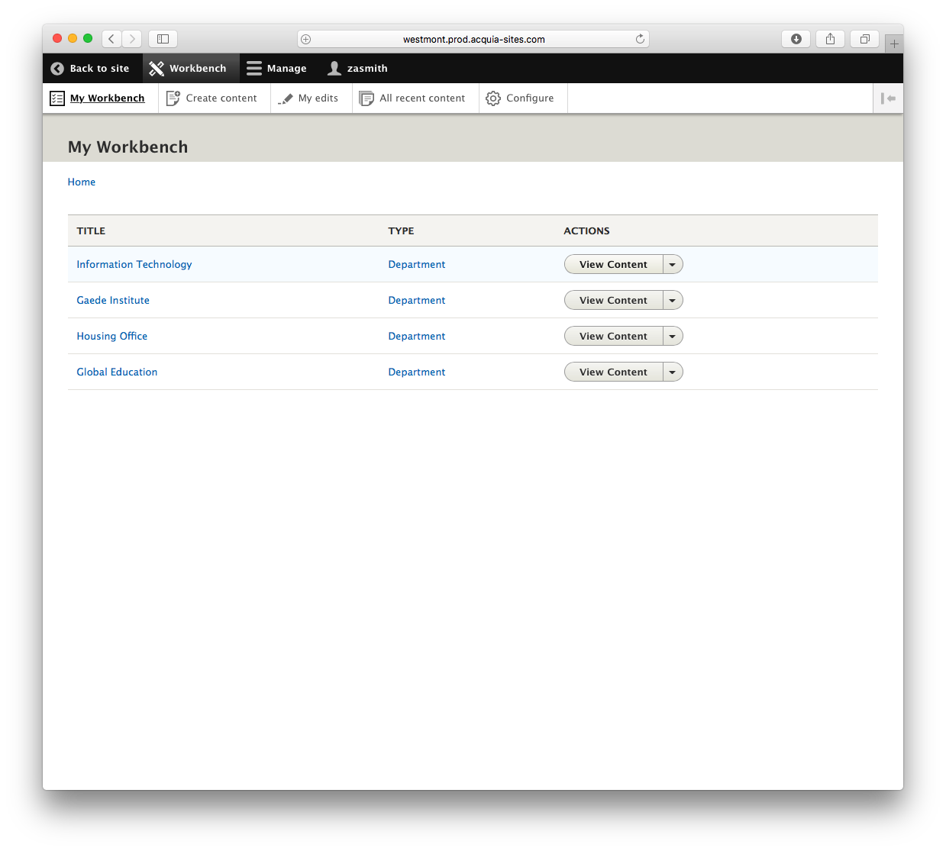
5. To edit a page, click the arrow next to “View relation” on the page you wish to edit, then click “Edit node”. You can also edit or delete the relation of the page (node) to your group.
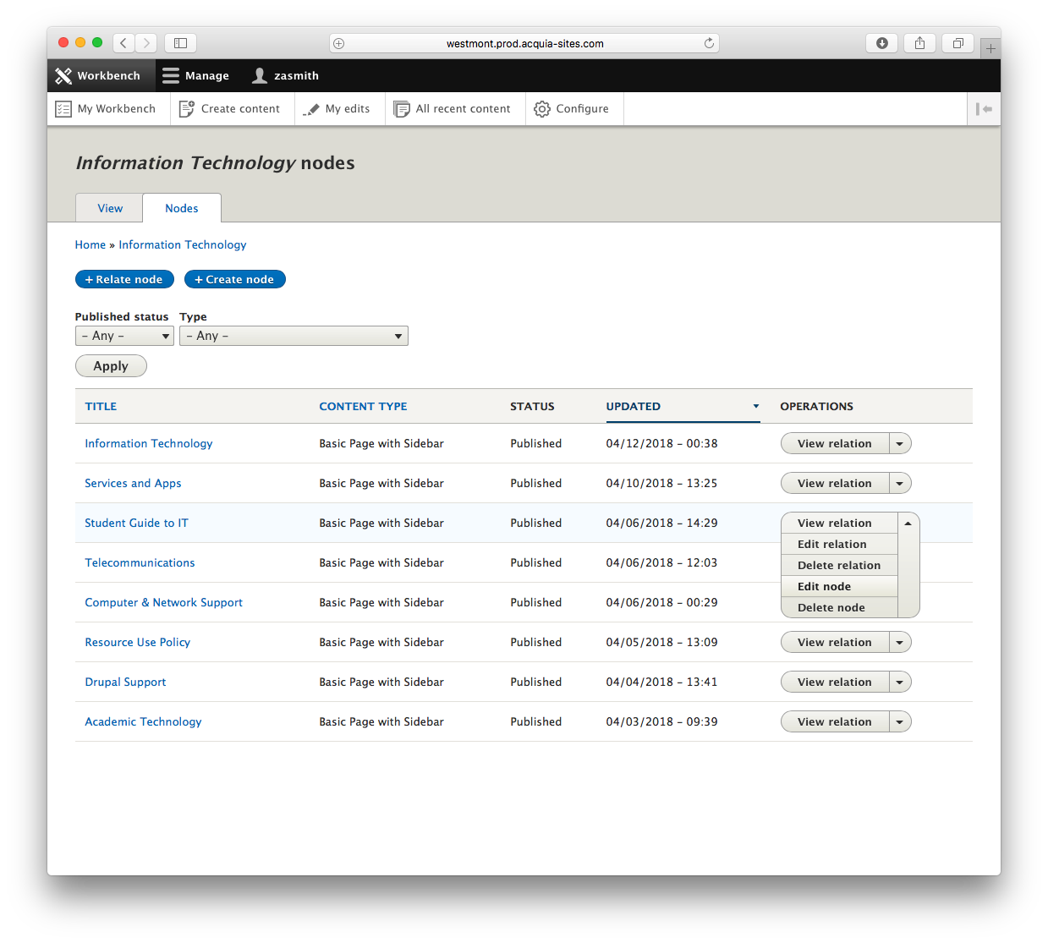
6. You’re editing an existing page! In the following sections, you’ll see more information about how these pages work and what you can do with them.
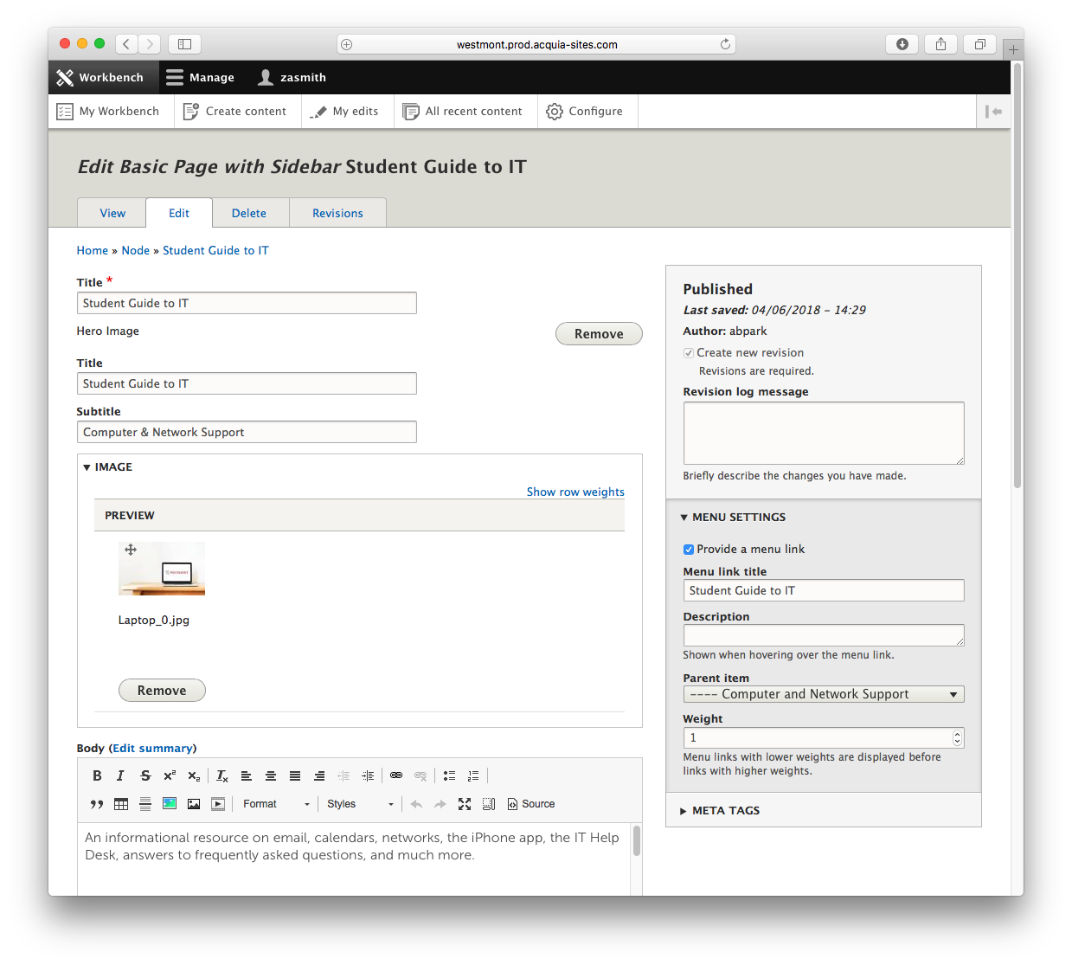

General Use Content Types

There are several content types, which exist within the system. However, the following content types have been created in order to a very flexible set of templates for general site pages:
- Primary Landing (e.g. Homepage)
- Landing Page with Menu (e.g. Student Life)
- Basic Page with Sidebar (Visit Westmont)
- Basic Page with Webform and Sidebar

Structure

Components have been implemented by using the Paragraphs module. Managing content within a component is a very simple and straightforward process. The general structure for these content types is:
- Title (to be displayed within the administrative interface and used as the URL reference)
- Hero:
  - Title
  - Subtitle
  - Image
- Body
- Component List
- Menu Selector

Recommended Authoring Steps

The recommended steps for authoring are as followed:
- Enter page title
- Enter display title, subtitle and image as desired
- Enter Body content
- Add components and related information as desired
- Select the type of menu to display. This will be either a Drupal Menu (manually managed) or a System Generated Menu (menu is automatically generated)
- SEO Featured Keyword (optional)
- Menu Settings: Select “provide a menu link”. The Menu link title will auto-populate.
  - Please note: The “Parent Item” must be set in order for the page’s URL and System Generated Menu (if used) to display the proper hierarchical structure.
  - If a “Parent item” is not set, the page will become a homepage for a new site.

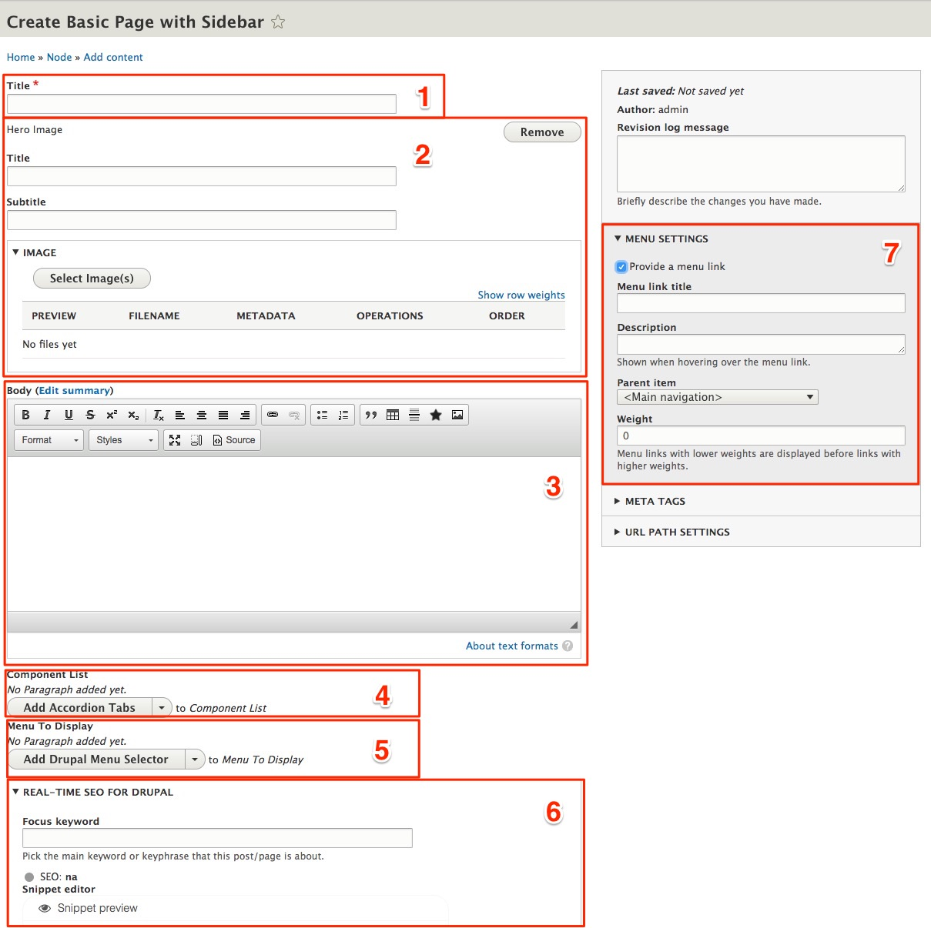
Specific Use Content Pages

Overview
Specific use content templates utilize most if not all of the same componentry as the General Use content types however; due to the need to be organized/listed these content types have been separated from the General Use content types. In some cases these content types may have predefined components already exposed within their content editing screen. Additionally, with the exception of Academic Departments/Programs, these content types are not assigned to sections within the site as they’re aggregrated and displayed automatically.

Academic Department/Program
The academic Department/Program content type should be used when creating an Academic Department/Program (Major, Minor, Pre-Professionals, Professionals) landing page. The primary distinction within this content type is the addition of the “Category” selector which permits the editor to assign the landing page to the corresponding category that will auto-populated on the Academics landing page.

Events
The Events content type is to be used when creating a new Event for display within the Events Carousel. When viewing the resulting page no styling has been applied due to the event linking to other destination pages.

News
The News content type is for the creation of News content that can be displayed throughout the site via the News Carousel or within the /news section of the site. The primary distinction within this content type is the ability to assign Audience, Department, Topic and Type taxonomies.

People
The People content type is specifically for the creation of People pages. These pages can then be accessed throughout the site via the People Carousel Auto Display component. The primary distinction with this content type is the ability to define the taxonomies of Departments and Tags.

Study Abroad Landing
The Study Abroad Landing content type specifically created for the display of Study Abroad Regions. It possesses some preset components as well as a freeform area for adding additional components.

Study Abroad Region
The Study Abroad Region is to be used specifically for the creation of a Study Abroad Region information page. Additional taxonomy information such as Major and Region is managed as well.

Components

Body

Input the main text of the page here. There are various formatting styles in the body section. These styles are also available in any component with a “content” box.

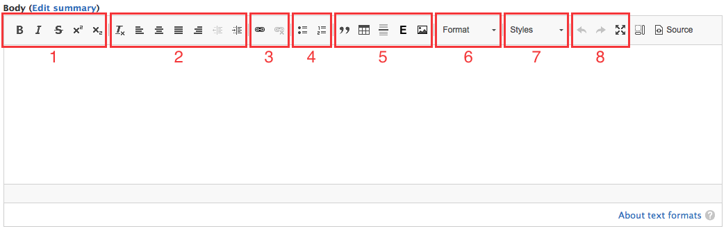

Text Options:

- Text appearance
- Choose whether your text is bold, italicized, or strikethrough.
- x² makes the text a superscript and x₂ makes it a subscript.
- Alignment and Indentation
- Remove all existing formatting
- Choose whether your text is left aligned, centered, justified, or right aligned.
- Increase or decrease indentation.
- Links
- To add a hyperlink, select the text and click the chain link button. To link to a page within the site, enter the page name in the “URL” box and select it. To link to a page outside of Westmont’s site, enter the full url.
- To change the hyperlink, double-click the linked text.
- To disable a hyperlink, click once on linked text and click the broken chain link button.
- Lists
- Format text in a bullet list or numbered list
- Media
- Format text as a block quote
- Insert a table. A dialogue box will pop up for you to enter the amount of rows and columns desired. To add or delete rows or columns in a preexisting table, right click the table and select the right option.
- Insert horizontal line in the text
- Embed media, such as pictures or videos, from the media browser
- Embed a picture by uploading from your files
- Format
- Choose how to format the text from a dropdown menu. This gives you different heading and paragraph types.
- Style
- Choose the style of the text from a dropdown menu.
  - For links, you may choose a button type
  - For bullet lists, you may choose a layout type
  - For regular text, you may choose red text or intro text options.
- Controls
- Undo or redo a change in the text box
- View the box in fullscreen mode. Click again to return to normal display.

Column Layout

Provides a grouped set of features. The structure has an overarching “Column Layout” which contains nested “Column Layout Items”. Can display 1-3 items
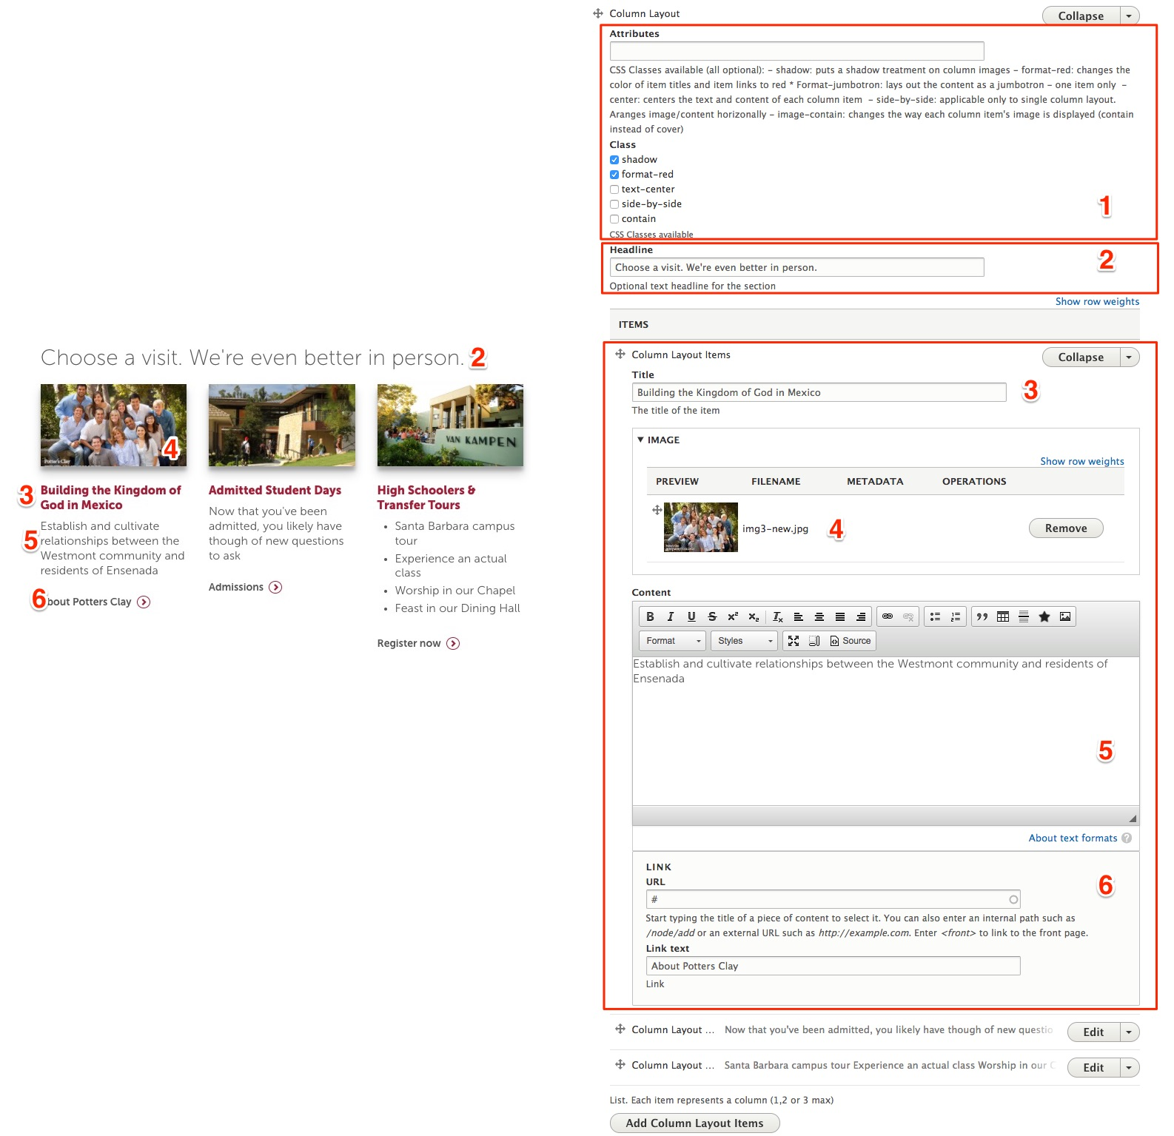
Column Layout:

- Attributes/Class:
- Input field provides a way for future CSS attributes to be applied. These attributes would need to be added to the site’s CSS.
- Class provides access to existing attributes that can be applied to all features
- Headline
- The headline to display for the group of features

Column Layout Item:

- Title:
- Title to display for an individual Column Layout Item
- Image:
- Image to display for an individual Column Layout Item
- Content:
- WYSIWYG (formatted text) to display for an individual Column Layout Item
- Link URL/Text:
- Link URL for an individual Column Layout Item
- Link title for an individual Column Layout Item

Image Carousel

Provides an image carousel. The structure has an overarching “Image Carousel” which contains nested “Image Carousel Items”.
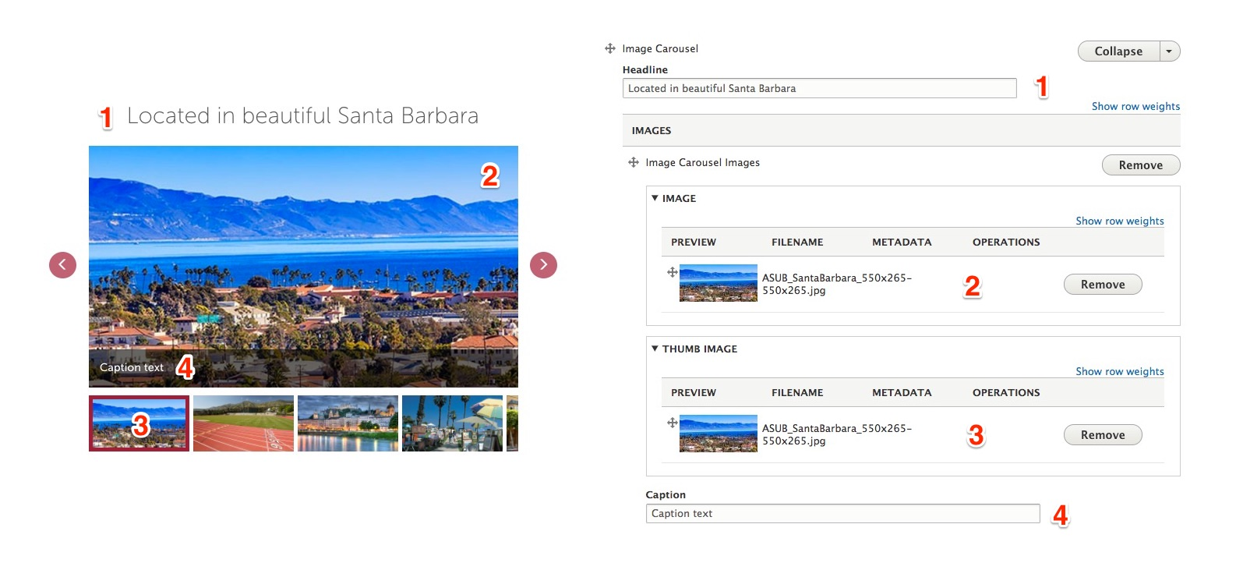

Image Carousel:

- Headline
- The headline to display for the Image Carousel

Image Carousel Images:

- Image:
- The content image to display
- Thumb Image:
- The thumbnail image to display (no need for the thumb image anymore, the system now generates the thumbnail automatically)
- Content:
- The caption to display for the image

Events Carousel

A system generated component that will display the results based on the provided configuration.
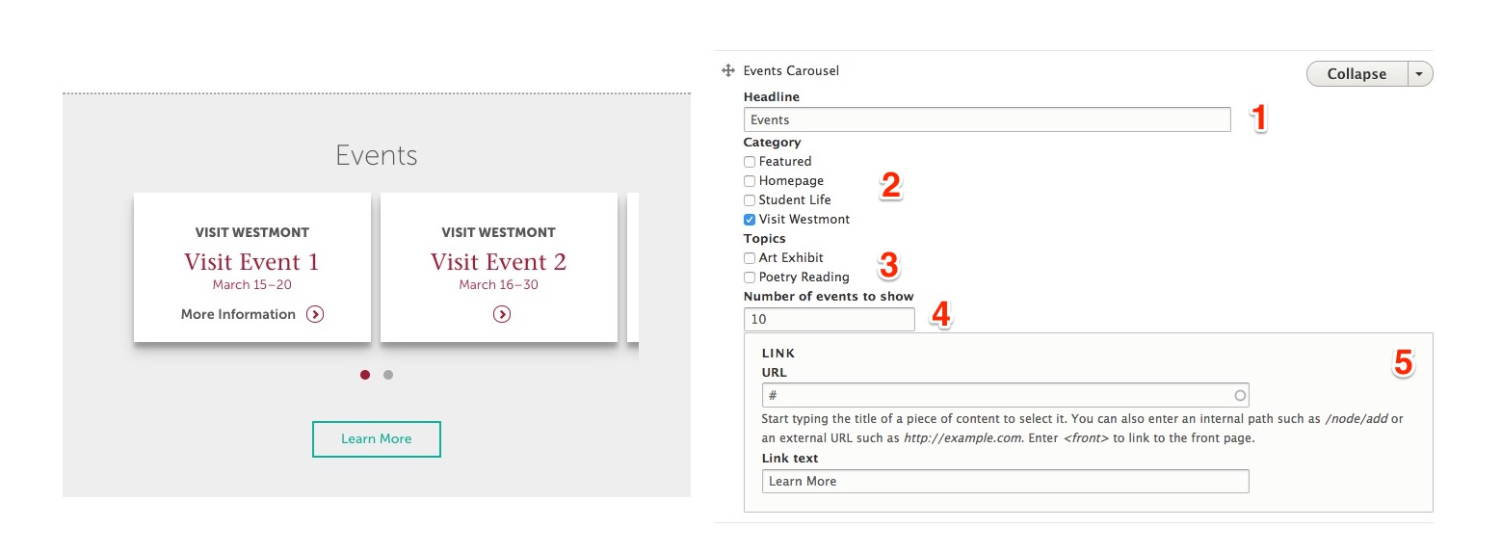

Events Carousel:

- Headline
- The headline to display for the Image Carousel
- Category
- The categories to use against
- Topics
- The topic(s) to filter against
- Number of events
- The number of events to display. Recommended maximum 10.
- Link URL/Text
- Link URL
- Link title

Accordion Tabs

A set of content tabs that offers an optional vertical or horizontal presentation.

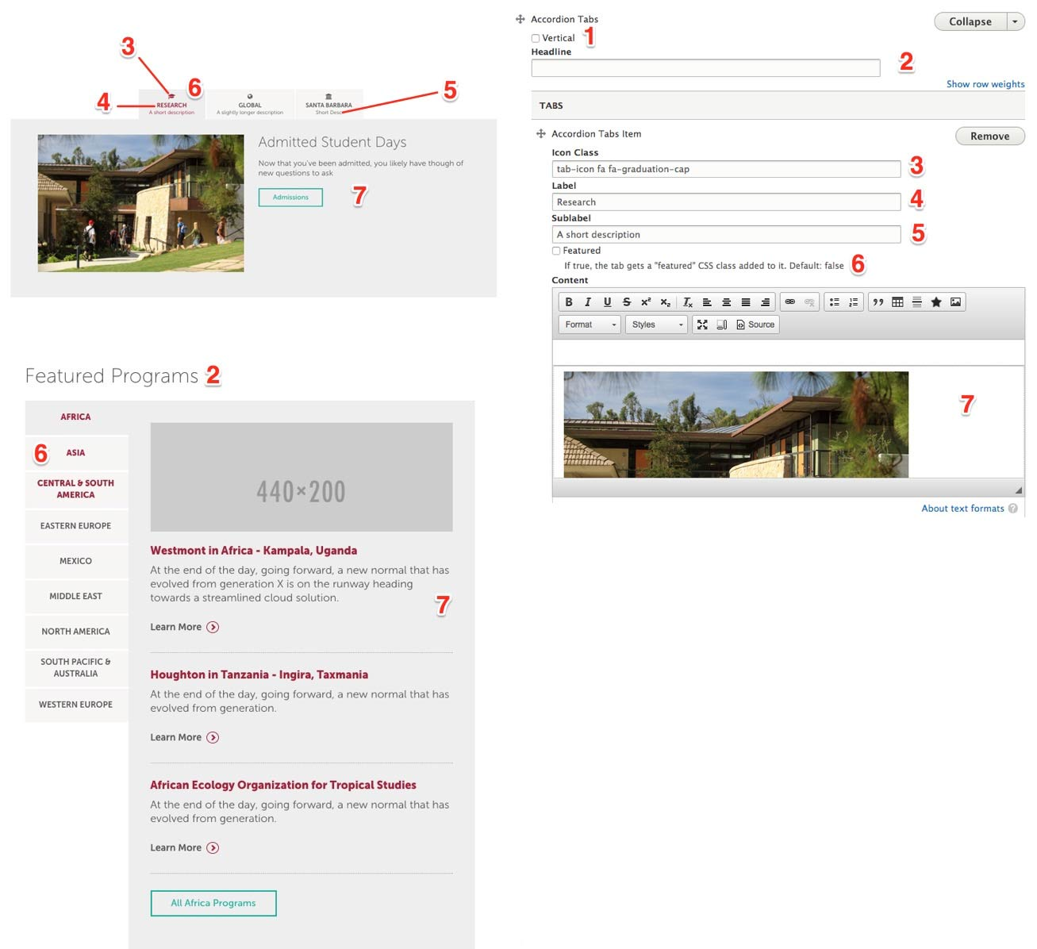

Accordion Tabs:

- Vertical
- Display the tabs either vertical or horizontal (default)
- Headline
- Optional headline to display
- Icon Class
- Optional icon class to display. The site currently includes all fonts provided by Font Awesome. These fonts can be used as icons by including the corresponding class “fa fa-desired_font”. Available fonts can be found here: http://fontawesome.io/icons/
- Label
- The tab label
- Sub-label
- The sub-label to display
- Link title for an individual Column Layout Item
- Featured:
- Display the tab label in red text
- Tab content
- WYSIWYG text input allowing for versatile content authoring

People Carousel

A listing of people (or other content) displayed as a horizontal carousel or vertical list.

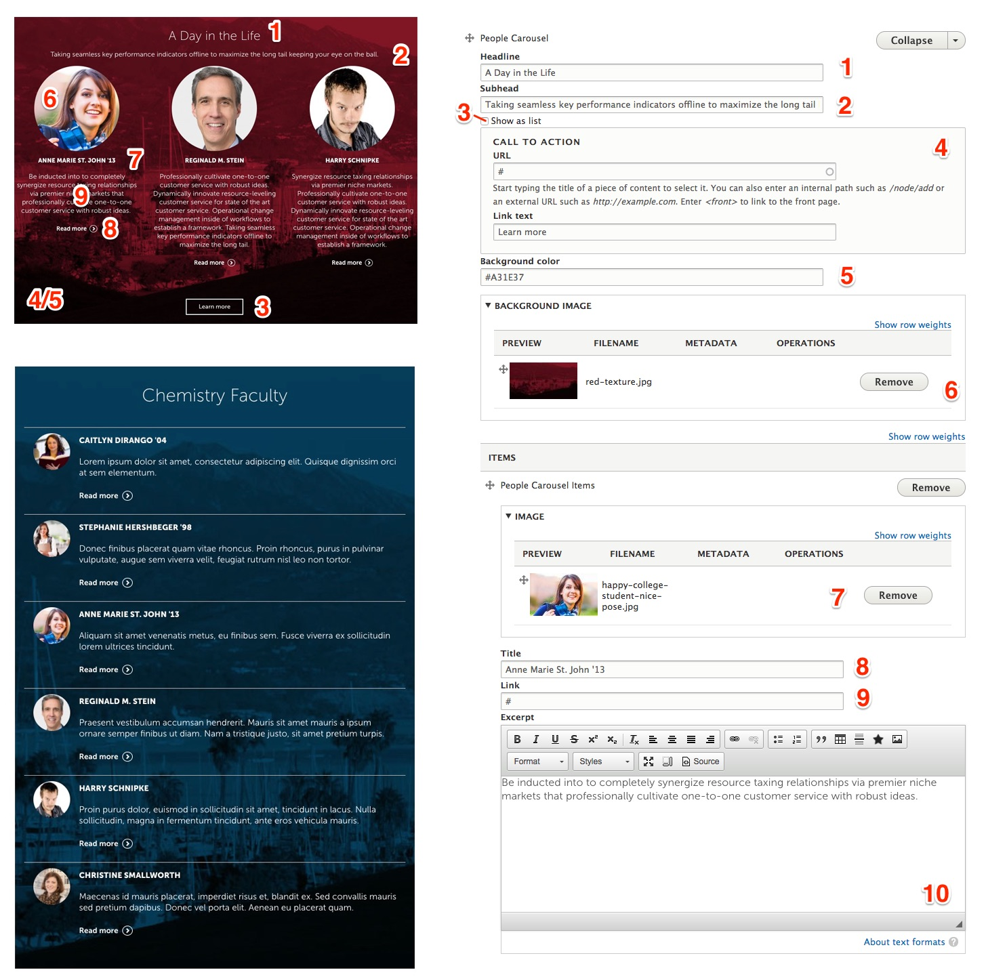

People Carousel:

- Headline
- Optional headline to display
- Sub-Headline
- Optional sub-headline to display
- Show as List
- Display content as a list or as a carousel (default)
- Link URL/Text
- Link URL
- Link title
- Background Color:
- Optional background color
- Background Image
- Optional background image

People Carousel Item:

- Image
- Image of subject
- Title
- Title of subject
- Link
- Link to subject detail
- Excerpt
- WYSIWYG input offering a brief description of subject

Infographic Layout

A one to three column display of infographics consisting of a foreground image and background image or color

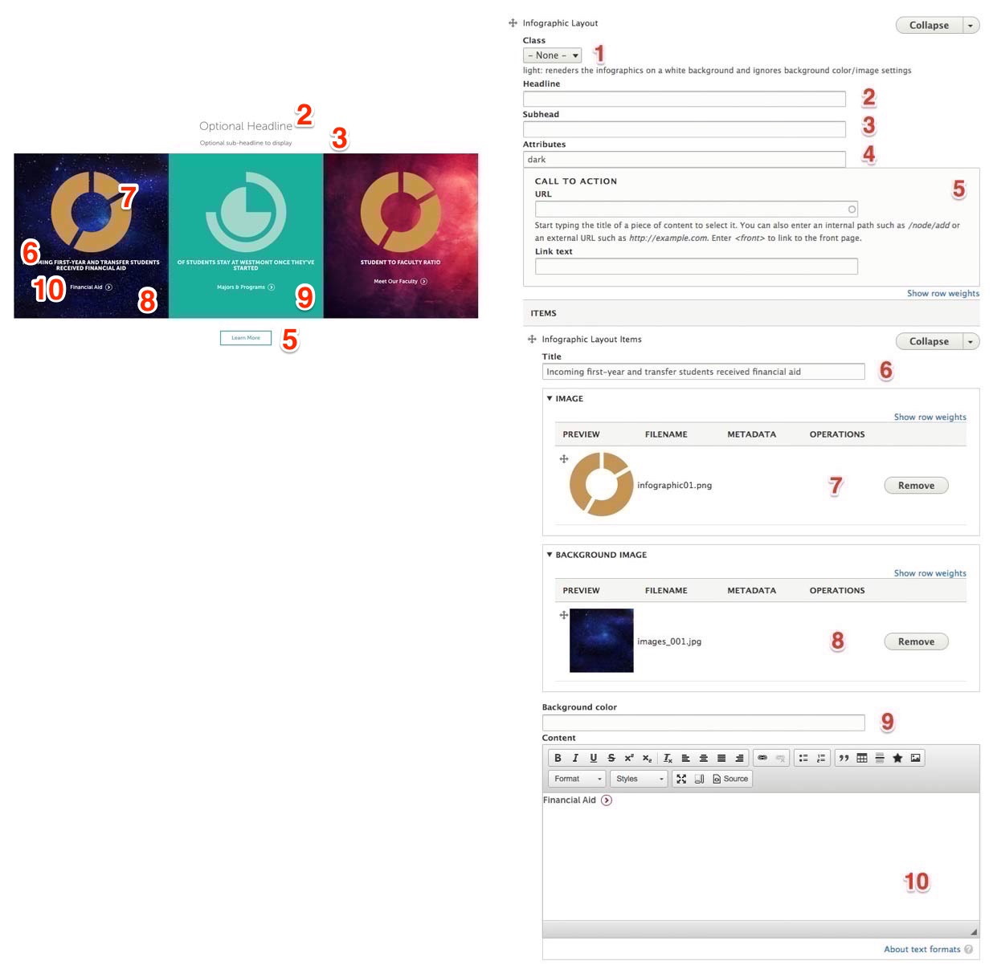

Infographic Layout:

- Class
- Optional “Light” class to display infographic on white background instead of default red background
- Headline
- Optional headline to display
- Sub-Headline
- Optional sub-headline to display
- Attributes
- Optional CSS attributes to add
- Link URL/Text
- Link URL
- Link title

Infographic Layout Item:

- Title:
- Title of the subject
- Image:
- Optional foreground image
- Background Image
- Optional background image
- Background Color
- Optional background color
- Content
- WYSIWYG input offering a brief description of subject

News Carousel

A system generated component that will display the results based on the provided configuration.

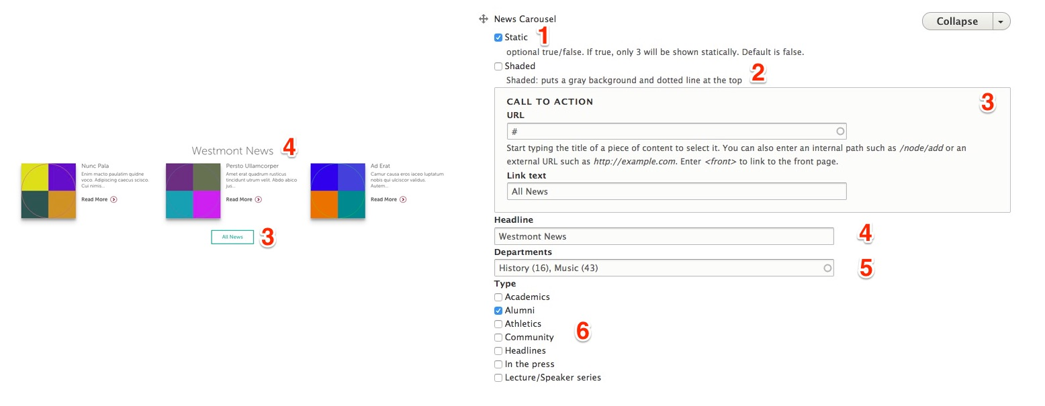

News Carousel Layout:

- Static
- Display a list of 3 or as carousel (default)
- Shaded
- Display with light grey background
- Link URL/Text
- Link URL
- Link title
- Headline
- Optional headline to display
- Departments
- Selection of which news department categories to include
- Tags
- Selection of which tags to filter against

Promotional Carousel

A carousel to display manually entered information or promotions

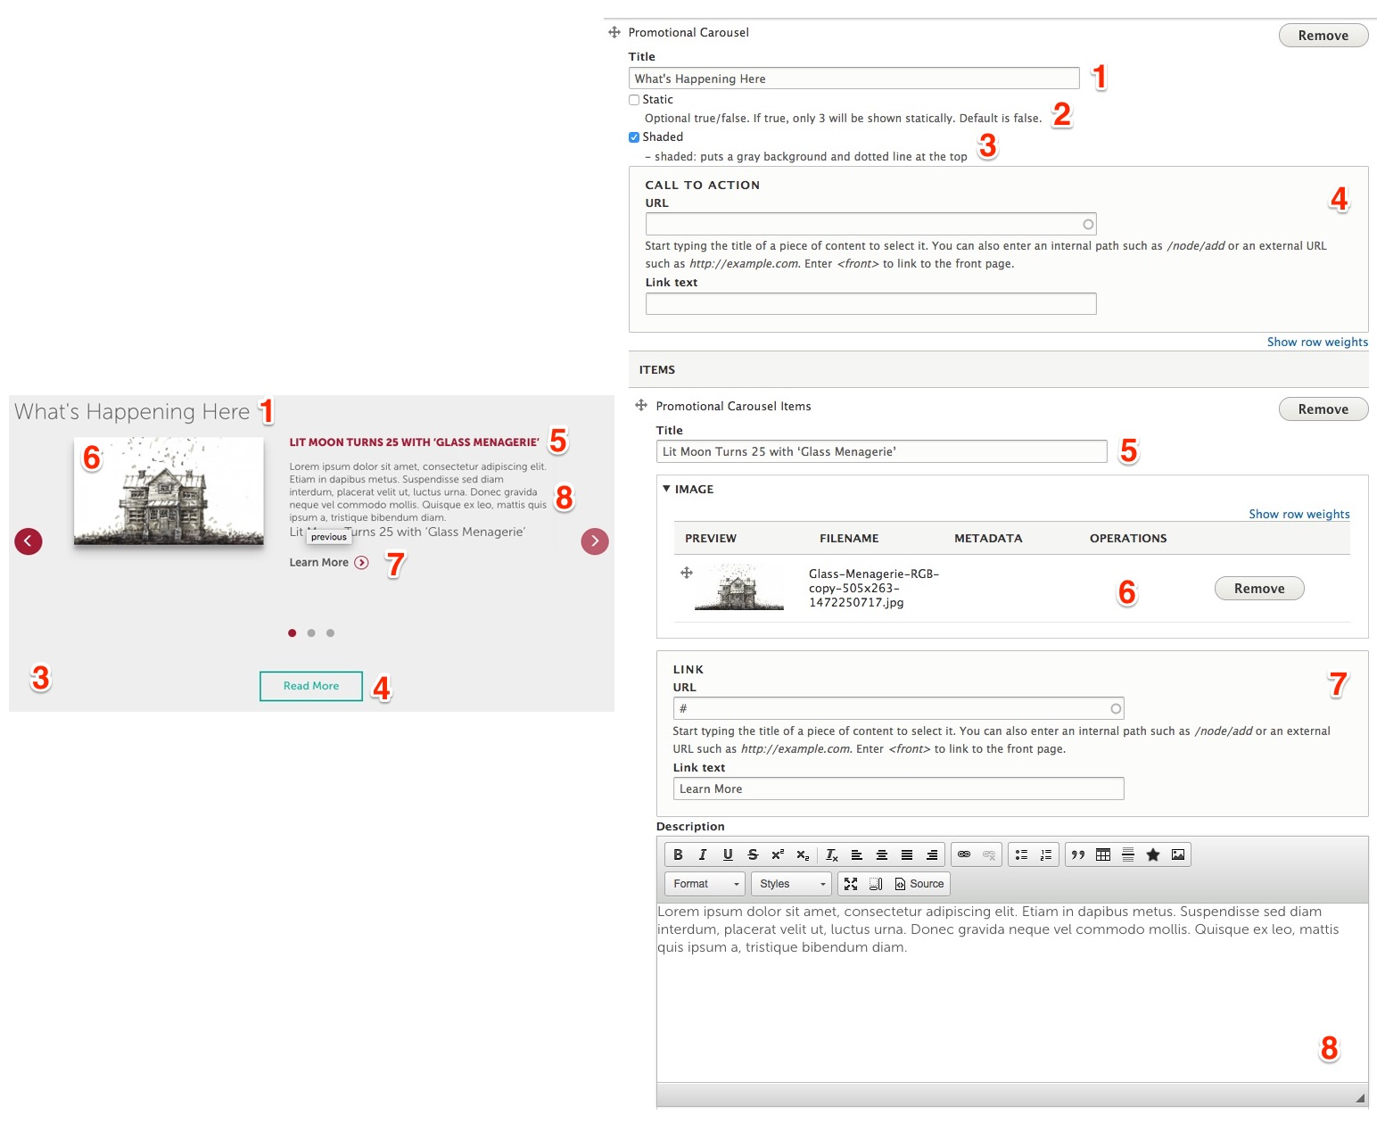

Promotional Carousel:

- Title:
- Title to display
- Static
- Display a list of 3 or as carousel (default)
- Shaded
- Display with light grey background
- Link URL/Text
- Link URL
- Link title
Promotional Carousel Items:

- Title
- Optional title to display
- Image
- Image to display
- Link URL/Text
- Link URL for individual promotional item
- Link title for individual promotional item
- Description
- WYSIWYG description information

Net Price Calculator

Net price calculator promotional area

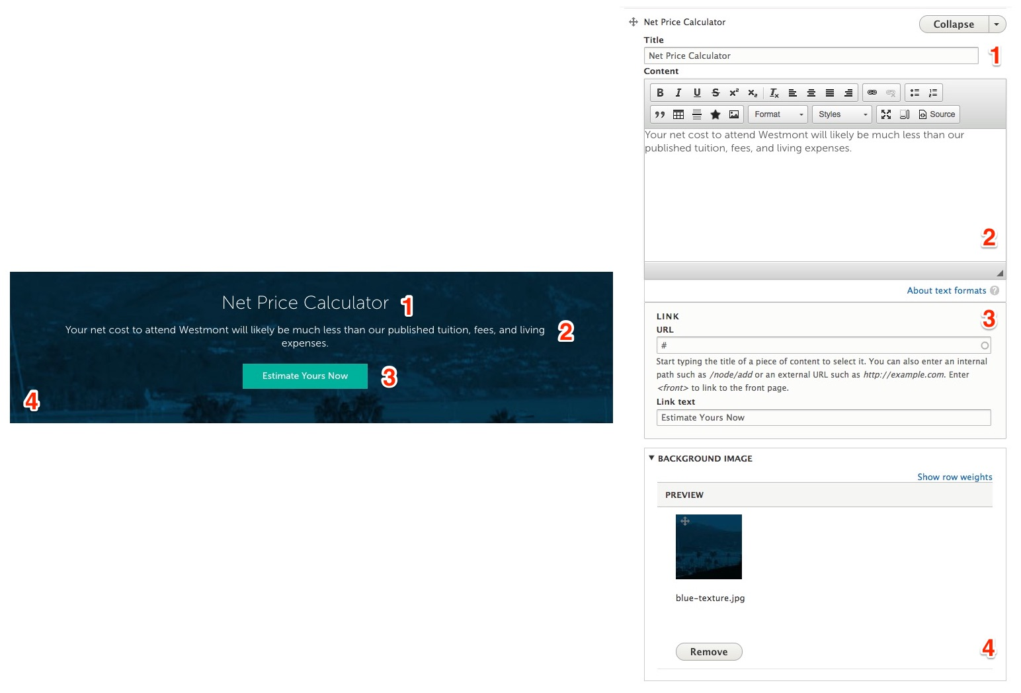

Net Price Calculator:

- Title:
- Title to display
- Content
- Description/detail information
- Link URL/Text
- Link URL
- Link title
- Background Image
- Image to display in the background

WYSIWYG Section

Formatted text input allowing for the display of various content layouts

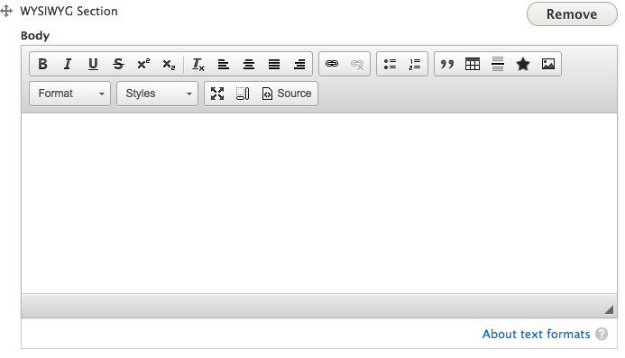

Menu To Display

Permits the selection of two different types of menus:
- Drupal Menu Selector: Display a manually managed Drupal Menu
- Dynamic Context-Aware Menu: Display system generated menu that displaying the hierarchy for the section that the content page is assigned.

