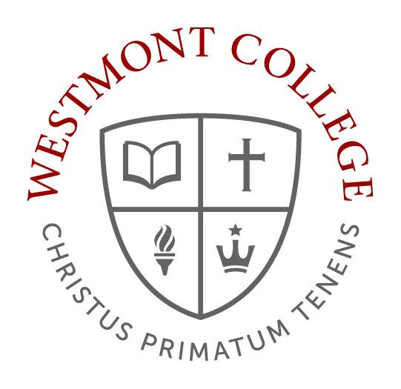

Westmont College
GE Course Syllabus Guidelines

Every course needs a syllabus. The college grants you considerable freedom to construct syllabi that reflect your own goals, pedagogies, and vision for your courses. There are, however, several requirements that must be included in all General Education course syllabi. The following guidelines define those requirements and offers some recommendations about how you might construct the syllabi for your GE courses.

Required Elements of Your Syllabus As an instructor, you will bring your own style and the expectations of your particular discipline to the format and content of your syllabus. But every syllabus should include the following elements:
- Course title, number, section, term, and year
- Where and when the class meets
- Your name, office location, preferred method of contact, office hours
- Books, materials, and other resources required for the course
- Course learning outcomes and how they will be assessed
- Main assignments and exams with due dates
- Policies for attendance, participation, usage of electronic devices in class, make-up work, and due dates
- Instructions for students with disabilities
- Academic integrity policy
- Course schedule

GE Course Syllabus Requirements. Please be sure to address the following questions. You may want to consult the General Education Combined Document, which contains interpretive statements and certification criteria for each GE course.
- What GE requirements does this course meet and why?
- What are the specific learning outcomes of the course and how are they aligned with the area General Education Learning Outcome(s) (GELOs)?

Few students arrive at college already hungry to learn everything we have to teach them. Most see the point of their major requirements, but few see the purpose of all the courses required for General Education. Westmont faculty who teach a GE course should be prepared to explain how their course contributes not only to their discipline but also to the liberal arts education that Westmont offers. Faculty should, of course, sketch such an explanation in general terms in their syllabi, but they should also take class time to make the case that the particular things students learn in that class – be it statistics or Spanish, philosophy or psychology – are “the contextual background, concepts, vocabulary, and skills necessary for understanding the world” and interesting in their own right. If no such case can plausibly be made, this may be evidence that the course content needs to be adjusted accordingly.

GE Course Syllabus Recommendations You can include attitudinal outcomes, such as civic engagement, professionalism, and respect for civility in interpersonal relations. There are several resources posted on the Educational Effectiveness website including Bloom’s Taxonomy, which can help you develop effective student learning outcomes.

The number and kinds of outcomes per course will vary; however, it is important that you keep the number of learning outcomes manageable for you. Since these are the outcomes that you will actually assess with specific tests, assignments, or other forms of evaluation, you should keep the number limited. Remember that outcomes need not capture all your goals and aspirations for your students. You can include broader, less measurable objectives when you answer the question above about aspirations.

Also indicate what activities in the course will enable you to determine whether students have achieved the course learning outcomes.

This section could also convey your aspirations for students in the course. Students will, of course, be evaluated on their performance on certain assignments and measured against certain GE learning outcomes. But you have many other aspirations about the hopes, abilities, curiosity, affections, and virtues that will be enriched by the course. You may want to convey something about the experience that you hope students will have working and learning together.

Remember that other colleges may look at this part of your syllabus to determine whether a student’s credits for the course will transfer to another institution.

Sample General Education Syllabus Excerpts
Course Learning Outcomes Section from PHIL-006: Philosophical Perspectives syllabus
II. Course Learning Outcomes
A. Relative to General Education: The main learning outcome for this GE requirement is this:
“Students who take a course in the "Philosophical Reflections on Truth and Value" Common
Contexts GE area will (at the end of the course) be able to articulate in basic terms the contribution of philosophical reflection to their Christian liberal arts education.” The specific student learning outcomes for the achievement of this are:
1. [Philosophy] Students will be able to (a) articulate and (b) think critically about
foundational questions of philosophy - especially foundational questions of particular interest
to Christians concerning knowing, being, and value.
2. [Liberal Arts] Students will be able to articulate some of the main components of a
Christian liberal arts education and the interrelation of philosophy and other areas of
academic study in the liberal arts.
B. Relative to departmental/major goals: With the introduction to logic course, this course is one of the bases of a major in philosophy. As an introduction to philosophy, it has three main goals:
1. To help you learn about philosophy. The course surveys philosophical fields, issues, positions, arguments, and concepts. It (a) provides models of both critical and constructive philosophical thinking and (b) provides philosophical materials (positions, arguments, and concepts) you can employ in developing a Christian worldview.
2. To help you learn how to do philosophy. In general, the course is designed to (a) help you learn to think critically and analytically about fundamental ideas and ideals and (b) to help you learn to think constructively and systematically about the nature of reality and the meaning of life. Papers, essay exams and class discussions will help you acquire these philosophical skills.
3. To help you learn to enjoy philosophy. Though philosophy is difficult, it can be interesting and even deeply satisfying. You will be encouraged to cultivate a desire to philosophize throughout your life.

Course Learning Outcomes section from CHM-005: General Chemistry I syllabus
Upon completion of this course, you will be able to:

Student Learning Outcome | Instructional Activity | Assessment
Apply relevant scientific and mathematical methods to analyze and solve problems effectively | Lecture  Laboratory Experiments | Problem Sets  In-class response  Quizzes  Exams  Laboratory Reports
Identify ways in which the scientific approach to knowledge can be used to investigate the physical and living world | Lecture  Laboratory Experiments | Problem Sets  Exams  Laboratory Reports
Survey the relationships between scientific knowledge and the Christian faith | Lecture  Discussion | Reflection Questions  Exams

